ftp L4 – Web Database Server
Step 0: Preparation
Before working on modifying an Ubuntu machine, we first must update the machine to make sure that it is up to date.
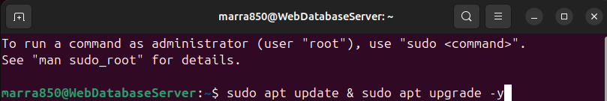
Once the update is done, it is preferable to restart the machine to make sure all of the updates are applied.

Step 1: Install Apache Web Server
To install apache, you simply need to write the command sudo apt install apache2. Once it’s done installing you can verify the installation by opening the browser and searching for localhost on the searchbar.
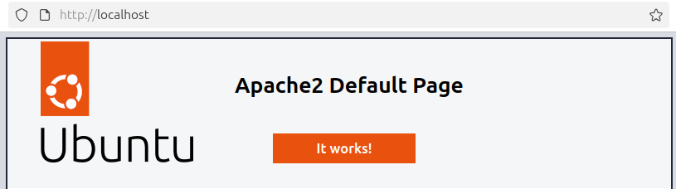
Step 2: Install MariaDB
To install MariaDB, we first need to run the command sudo apt install mariadb-server -y
Once it is done with installing, you run the command mysql_secure_installation to remove insecure default settings
Step 3: Install PHP
To install php, you run the command sudo apt install php, then wait for it to finish. To test if it works you can run the command php -v and it will give you the version of php
Step 4: Install phpMyAdmin
To install phpMyAdmin, you run the command sudo apt install phpMyAdmin and then you answer the following questions and fill out any inputs.
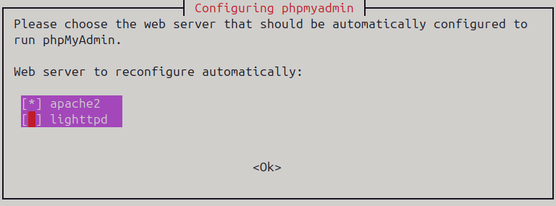
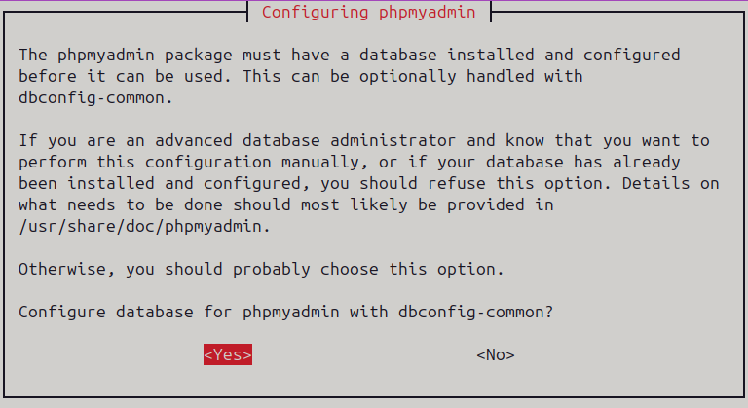
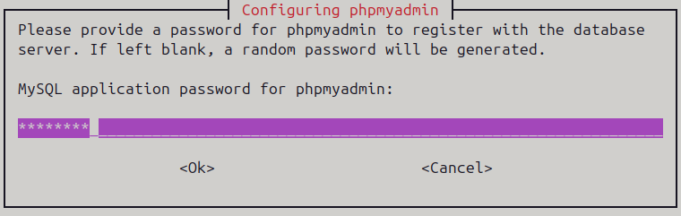
Step 5: Create Test Website & Database
To create a database we simply go to http://localhost/phpmyadmin then you fill out your login credentials and create your database to your liking.
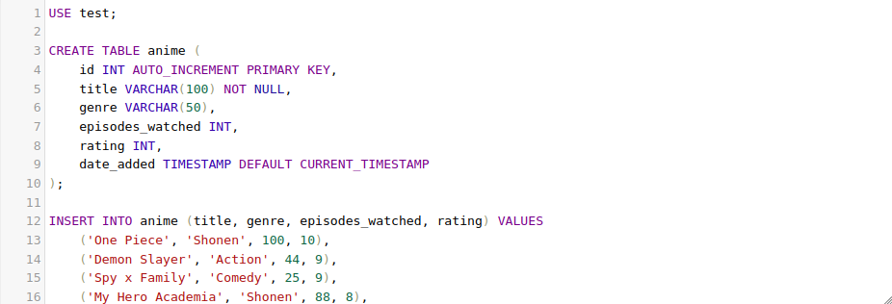

Once done with it, you can finally work on your website by going to the document root, which by default is /var/www/html then create the file.

Step 6: Opening the Ports
To allow connection to the website remotely, you need to allow all of the apache ports on the fire wall and optionally ssh if you want to work on the server remotely.
